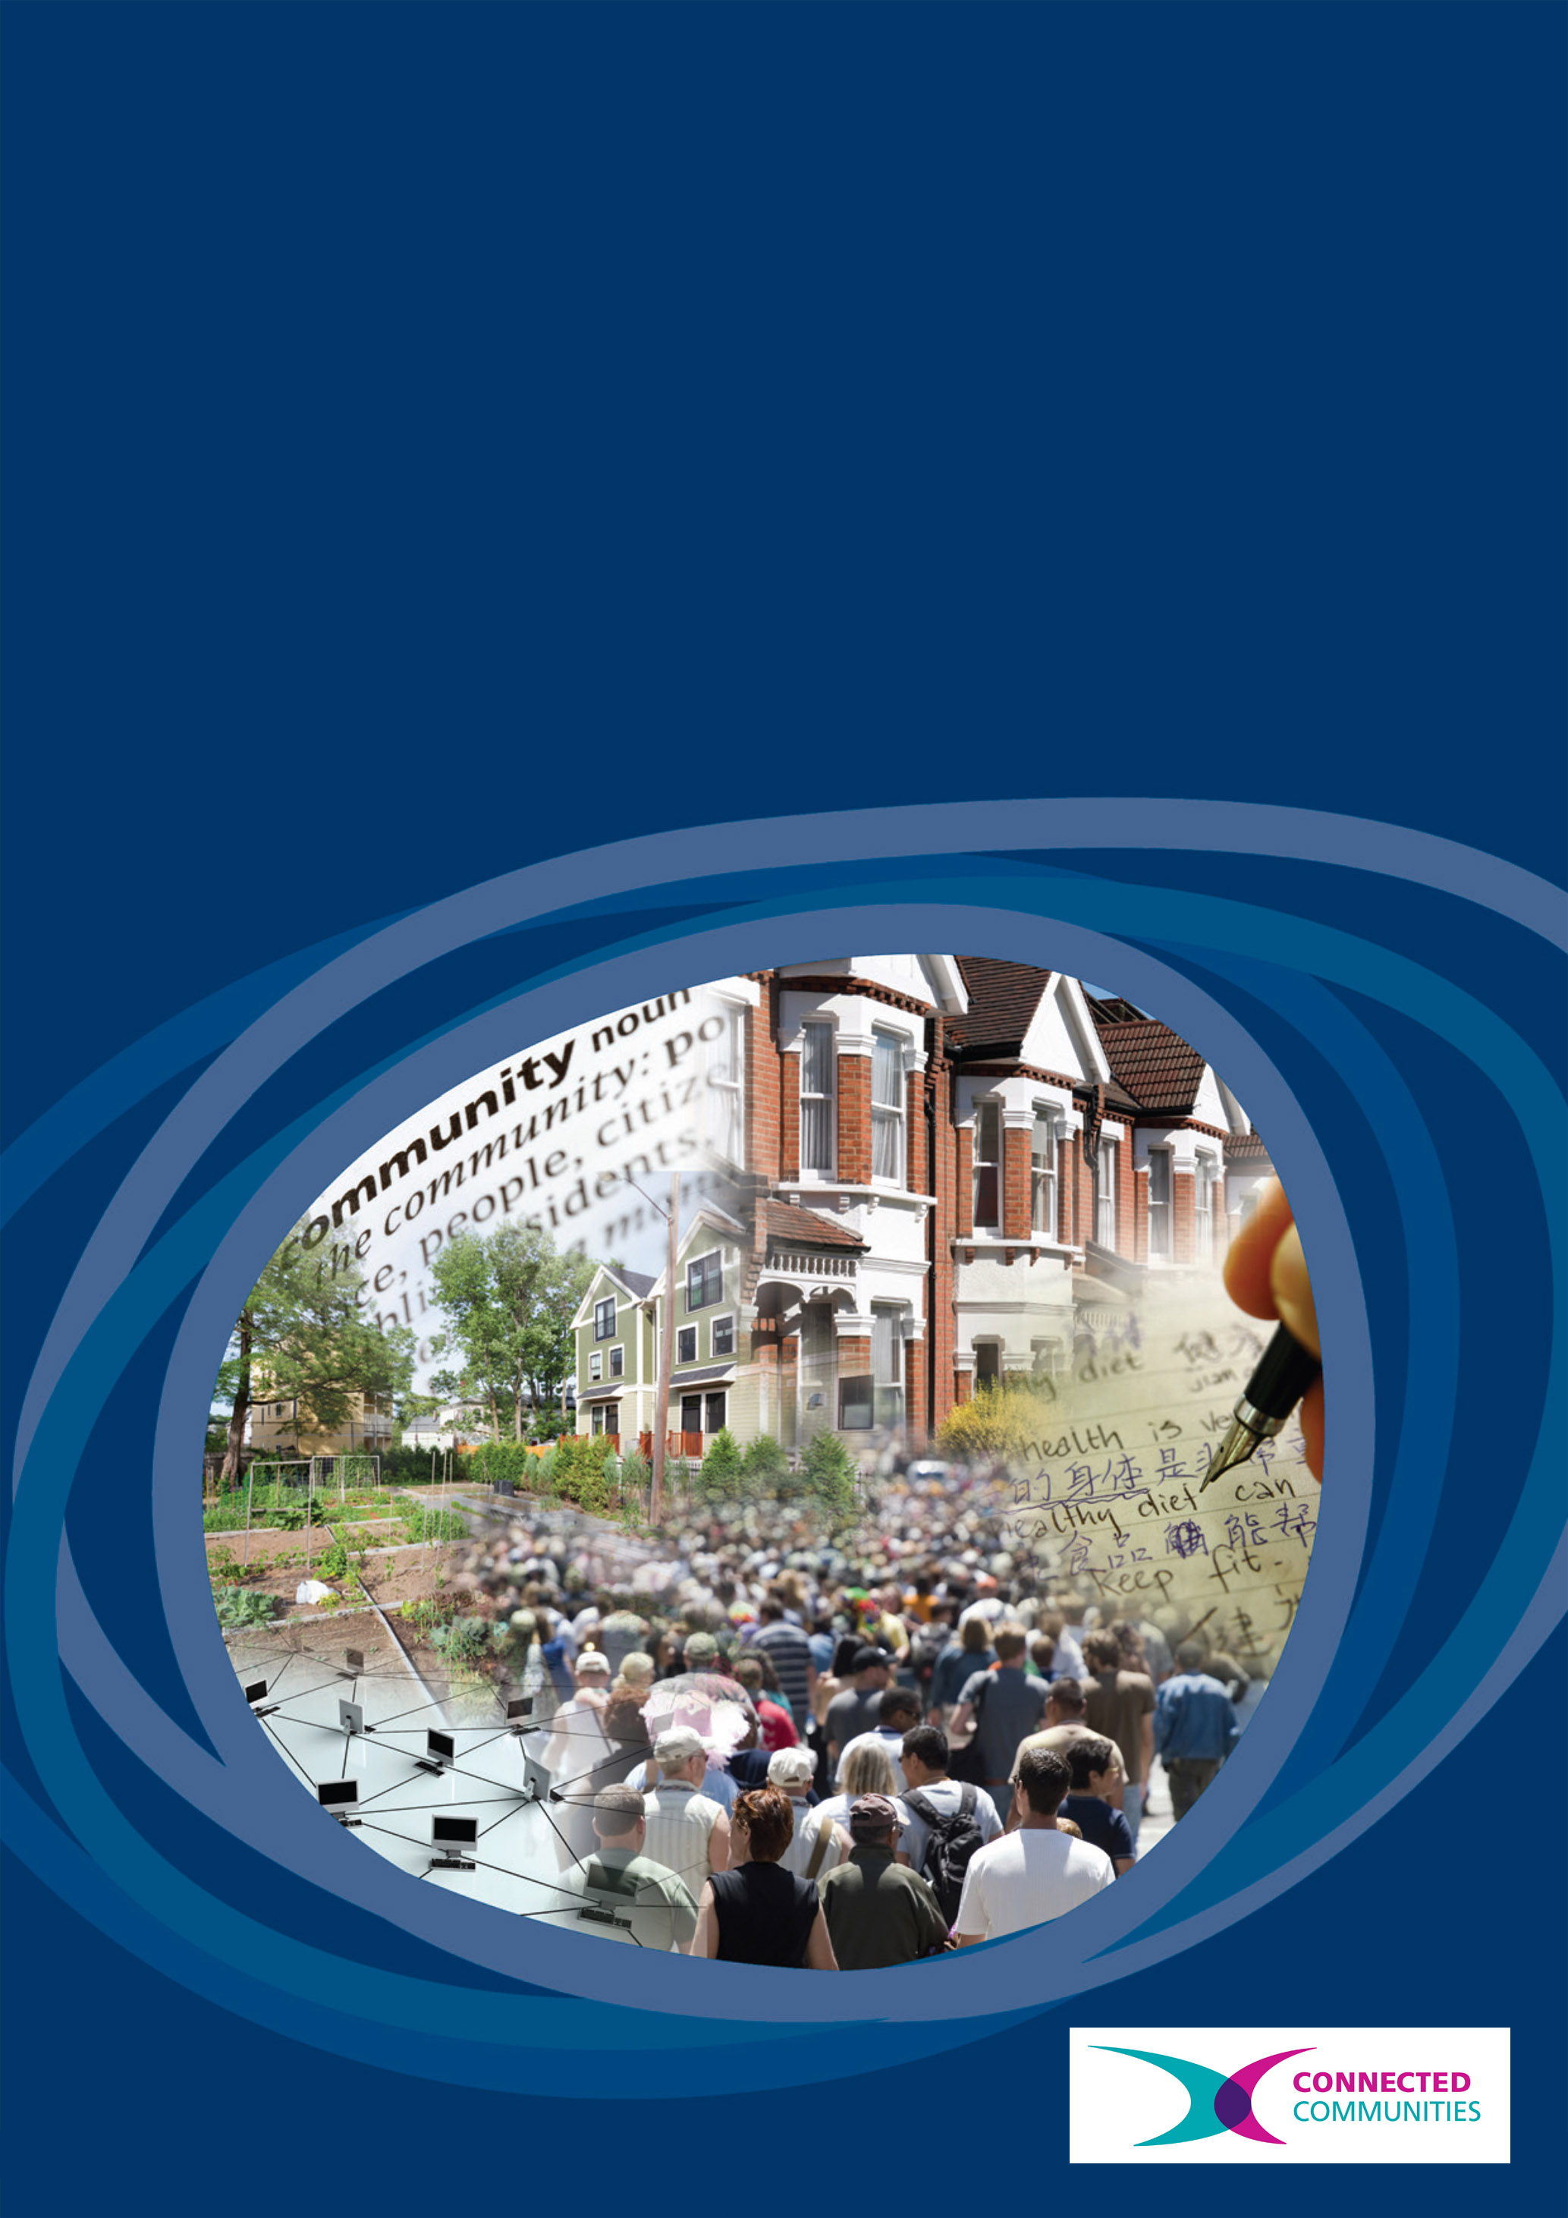
Connected Communities
How should heritage decisions be made?

How should heritage decisions be made?

Project Team
Martin Bashforth, radical family historian and York’s Alternative History
Mike Benson, Director, Bede’s World
Tim Boon, Head of Research and Public History, Science Museum
Lianne Brigham, York Past and Present
Richard Brigham, York Past and Present
Karen Brookfield, Deputy Director (Strategy), Heritage Lottery Fund
Peter Brown, Director, York Civic Trust
Danny Callaghan, Independent Consultant (Public Art, History and Engagement) including The Potteries Tile Trail (HLF All Our Stories)
Jean-Phillipe Calvin, Composer and Researcher
Richard Courtney, School of Management, University of Leicester
Kathy Cremin, Director, Hive
Paul Furness, Writer and Historian
Helen Graham, School of Fine Art, History of Art and Cultural Studies and Centre for Critical Studies in Museums, Galleries and Heritage, University of Leeds
Alex Hale, Archaeologist, Royal Commission of Ancient and Historical Monuments of Scotland
Paddy Hodgkiss, Riccall Community Archive Co-ordinator
John Lawson, Storyteller, Loftus
Rebecca Madgin, Urban Studies, University of Glasgow
Paul Manners, Director, National Co-ordinating Centre for Public Engagement
David Robinson, Technical Editor and Musician
John Stanley, Writer and Electronic Musician
Martin Swan, Musician and Educator
Jennifer Timothy, Senior Building Conservation Officer, Leicester City Council
Rachael Turner, Director, MadLab and The Ghosts of St Pauls (HLF All Our Stories)

Key words
Heritage, museums, decision-making, participation, planning, conservation, electronic music, co-design.

‘How should heritage decisions be made?’
Executive Summary and Introduction
‘How should heritage decisions be made?’ was funded as one of nine Connected Communities Co-Design Development Awards. The funding gave the time and space for fourteen of us who work in quite different contexts – funders, national and regional museums, local authority conservation teams, different academic disciplines and people who are activists about their own heritage – to collaborate between February and May 2013 to design a research project which we have since carried out, with more people actively shaping of the direction of the research since then.
Through our initial codesign phase we decided that our purpose was to explore how participation in heritage decision-making can be increased from wherever you work or live and whatever your position – professional, researcher or someone who cares about your own culture and place. Our research was generated through two distinctive ways of working: 1) Learning from each other through reflecting on, and articulating, the principles of innovative work already undertaken by practitioners in the research team; 2) Experimental action in different organizations and places (from the Science Museum to Royal Commission of Ancient and Historical Monuments Scotland; from Leicester to York).
Deriving from these ways of working came four modes of practice that might help all of us – and others in similar positions – increase ‘participation’ in heritage decision making: Act: Make change from where you are; Connect: Cross boundaries and collaborate; Reflect: See your work through other people’s eyes; Situate: Understand your work in context.

A much fuller account of the project can be read in our project booklet How should heritage decisions be made?: Increasing participation from where you are.
The booklet can be downloaded from: www.heritagedecisions.leeds.ac.uk

Phase 1: Co-design (February 2013-May 2013)
Our approach to the Phase 1 co-design process was to draw into dialogue the different perspectives within the team and for each of us to see our own ways of working through each other’s eyes. We developed our research design through a number of steps. In Step 1 (‘Entry Points’) and Step 2 (‘Scoping the issues’) our aim was to generate questions. We did this through workshops run by different members of the team and lots of conversations. In Step 3 (‘New perspectives’) we then tested our emerging ideas by broadening out the numbers of people involved in our discussions through the Research Team’s ‘day in the life swap’ (for example, Rebecca Madgin spent a day with Alex Hale at RCAHMS, while Danny Callaghan went to Historypin and Richard Courtney to Groundwork). We also tested the resonance of our ideas with wider networks and groups (via meetings/discussion in our institutions and groups, via our blog and mailing list). In Step 4 (‘Making Decisions’) we came back together to narrow the broader questions into ‘aims’ and a methodology and finally, in Steps 5 and 6, we drew our application together for it to be submitted for Phase 2 funding to the AHRC.
Phase 2: Research Design
Through our Phase 1 co-design process we identified a series of questions we were interested in exploring (see Appendix 1 for full list of questions). Central to our thinking were the issues raised by ‘participation’:
- What participation is: The meaning of ‘participation’ is often opaque and is often used far too loosely to describe attendance at events, volunteering or consultation – we wanted to tie participation to the sharper and more specific idea of ‘decision making’.
- Where participation happens: Participation is too often limited to a range of established practices (such as small display interventions in museums) and to silos (for example, learning teams) – we wanted to think about participation systemically within whole organisations and places.
- How participation feels: ‘Participation’ is often seen as hard, painful and characterized by conflict, owing to the inequalities and exclusions it seeks to breach – we wanted to draw out the human and social ways in which we can all feel more able to influence things that matter to us.
- The politics of participation: Although celebrated in some quarters, ‘participation’ remains politically contested. Questions often asked are: Can direct public engagement with decision making deal with complex information? Can participation be scaled to involve more than the ‘usual suspects’? – we have sought to address criticisms of participation through articulating more fully our practices and through modelling alternatives.

In addressing participation in heritage decision-making we were drawn to systems thinking and particularly its articulation through Danny Burns’ Systemic Action Research (2007). At Workshop 1, we developed a guiding motto to sum up our other emerging questions and to keep us on track in Workshop 2: ‘the conflict is how different people value different things in different ways, at different times and for different reasons’. As such, we thought that heritage might be usefully imagined, following Burns’ principles systemically because ‘complex issues cannot be adequately comprehended in isolation from the wider system of which they are part’ (Burns 2007: 1). This meant we needed to 1) take ‘into account the whole’ (how ‘heritage’ is made up in relationship to other things, systems, groups and logics); 2) ‘seek meaning in complex patterning of interrelationships between people and groups of people’ and 3) ‘look at interacting dynamics’ and crucially ‘identify boundaries and their effects’ (Burns 2007: 21, 24). To understand how heritage decision-making works, we wanted to actively use our different places ‘within’ it and experiment with ‘heritage’ in different ways to see it anew.

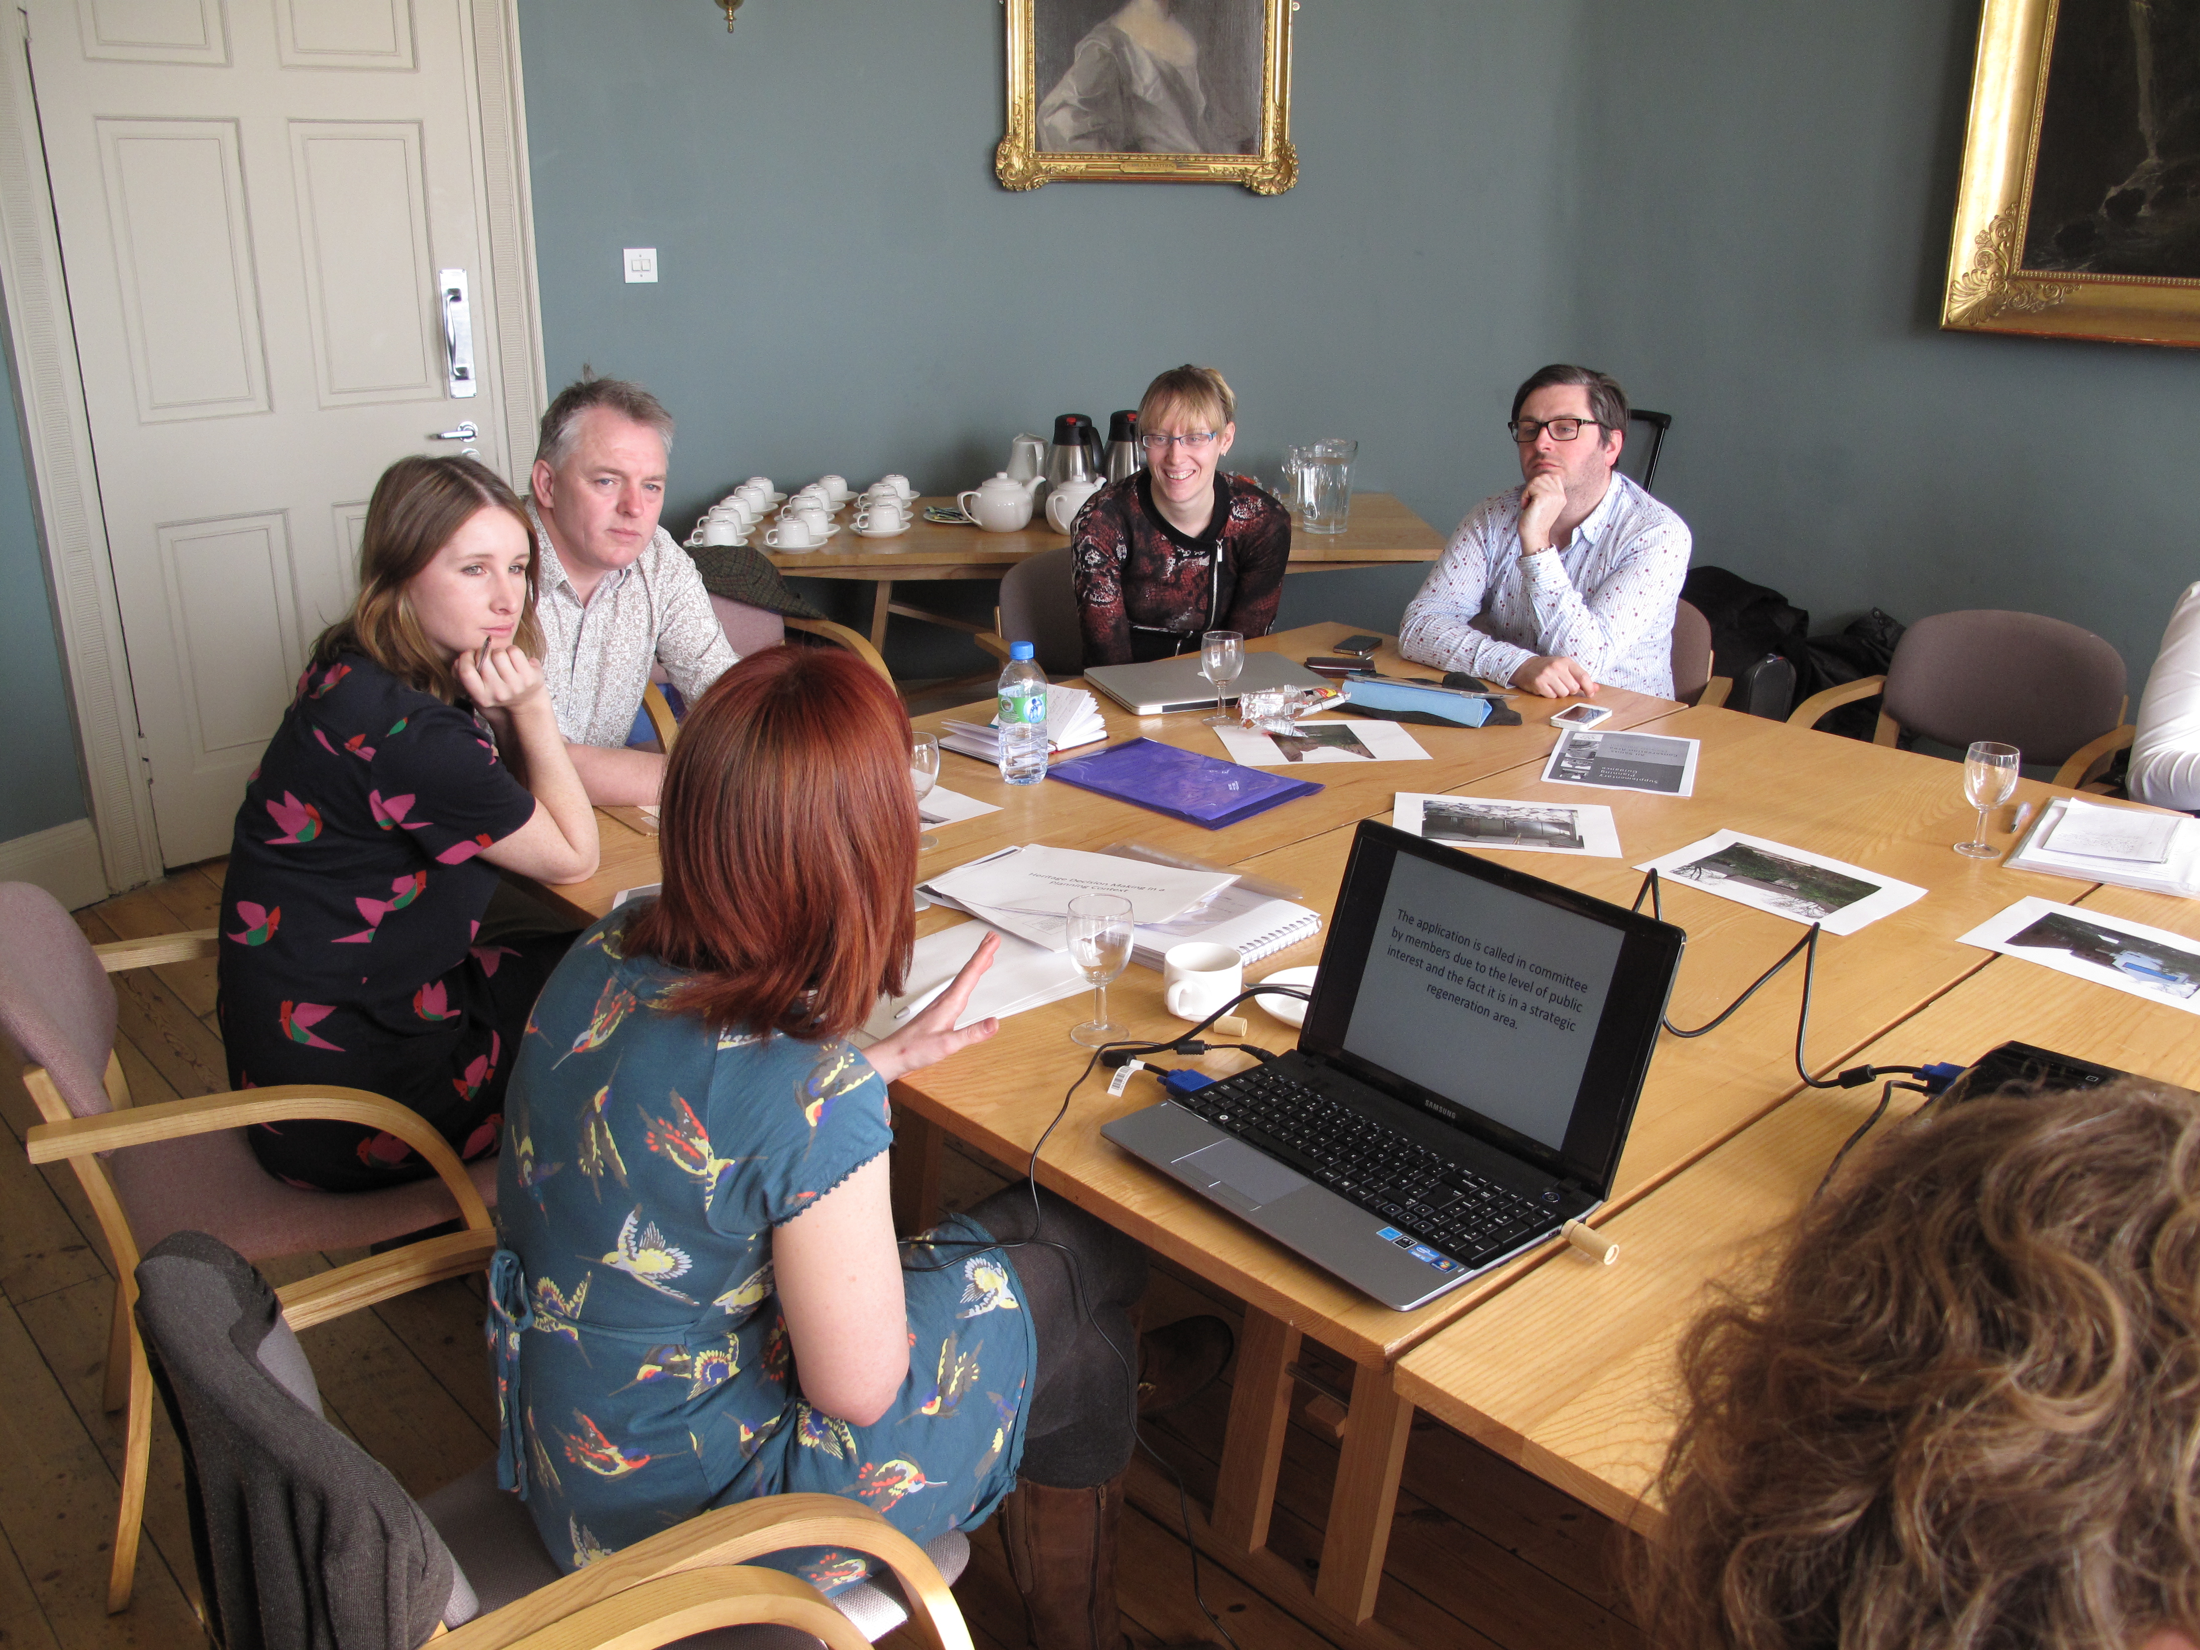
The research team explore the planning process with Jenny Timothy, Senior Conservation Officer, Leicester City Council, at our first workshop in Bede’s World

Testing our research plan
Before we entered our research phase we decided to test our ideas with other people – the interactions we had really helped us to see some of the assumptions in our plan, refine our thinking and adjust our approaches. We did this through hosting a workshop at Manchester Digital Laboratory in October 2013 and, via an open call, invited others to join us. The workshop was based around a huge piece of paper and we worked with an illustrator to help us visualise heritage decision-making systemically. We began with the apparently ‘simple’ decision making process of a building becoming ‘listed’. Then – through a stepped process – we worked together to unpack this ‘simple’ decision making process and to spin out from there the complexities and issues. The drawing became a shared point of connection as we went off in different directions to carry out our research.
The image produced through the workshop hosted by MadLab in October 2013.

Research strands:
There were six research strands.
1) Heritage as a living stream: Distributed decision-making and leadership at Bede’s World
At Bede’s World – and drawing on work they’d done together at Ryedale Folk Museum – John Lawson, Kathy Cremin and Mike Benson reflected on their shared learning and specifically their approach to distributed leadership.
John Lawson, Storyteller, Loftus, Kathy Cremin, Director, Hive and Mike Benson, Director, Bede's World
If a north star of the mission and principles guide the museum, this will be seen across that museum in the behaviours and conversations. This social museum will pioneer decision-making that turns the triangle of hierarchical decision-making on its head, with a mission and governance informed by users and beneficiaries of the organisation’s work. Our north star mission is that which nourishes the roots of a social space for heritage, that values the expertise and knowledge of different people and that – like an spinning atom - enables leadership to shift and change according to need will be a museum where linear hierarchies are redundant. In this model, decisions are made by the right person, at the right time, in the right place.
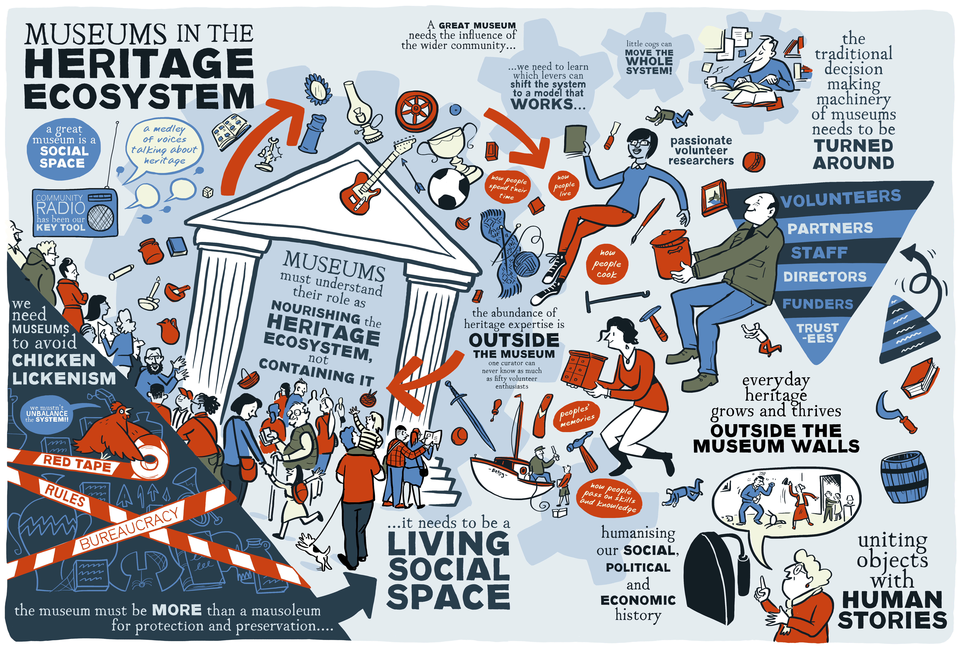
John Lawson, Kathy Cremin and Mike Benson’s approach to museums as a social space and situated in wide ecosystems.
2) College Court: Processes and Rules versus Intuition and Interaction
The significance of a listed building is often imagined as a stable and fixed part of the planning process. However this strand of the project sought to explore the more complex social interactions that take place through one specific example in Leicester, College Court. In this project the collaboration between Jenny Timothy, a Conservation Officer and a team of architects and developers saw the building’s meaning becoming more and more explicit through the process of working together. Interviews conducted by Rebecca Madgin showed that the social and emotional dynamics underpinned an iterative negotiation, in place of rules or any simple moment of ‘decision’.
They did all the stuff that you need to do for your application, so the statement of significance and the justification and what was happening (yet the building’s significance) never felt like it was explicit, it kind of seemed to grow as you went along; and it wasn’t actually until it was kind of all finished and we were stood there that people actually then started to explicitly say, actually this is really important, it’s a really beautiful piece of architecture, it’s a really nice building. But all the way along you could feel people’s attachment to the building growing, and that the understanding of the significance of the building growing; and by turn, how much they cared about it kind of growing.
(one of the participants in the College Court project)
3) The Science Museum: An experiment in democratising collecting
At the Science Museum an action research project was created: How should decisions be made about what museums collect? Most often, participation in museum decision-making is pushed into organisational silos, or focused on short-term interventions. The electronic music co-collecting project experimented with a different model: we brought together experts from inside and outside the museum. The team’s discussions questioned a key tenet of museum practice; that use today endangers preservation for the future.
By the end of the project the group had made successful cases to the Museum’s Collecting Board, and ran ‘Synth Bingo’, an event at the Museum’s popular ‘Lates’ evening opening.
Martin Swan, Musician and Educator
If you engage the network of geeks out there then you create a community with ‘a curatorial head on’. They will say – ‘we will look for those things’. You’re creating a community of curators. But as soon as you stop playing them, synths start to decay. They become less and less the thing that made them worth collecting. As they become less and less viable as instruments. They also become less and less interesting to the geeks, the very people who would want to enthuse about the objects to other people. And these are also the people who could maintain them and could get them going again.
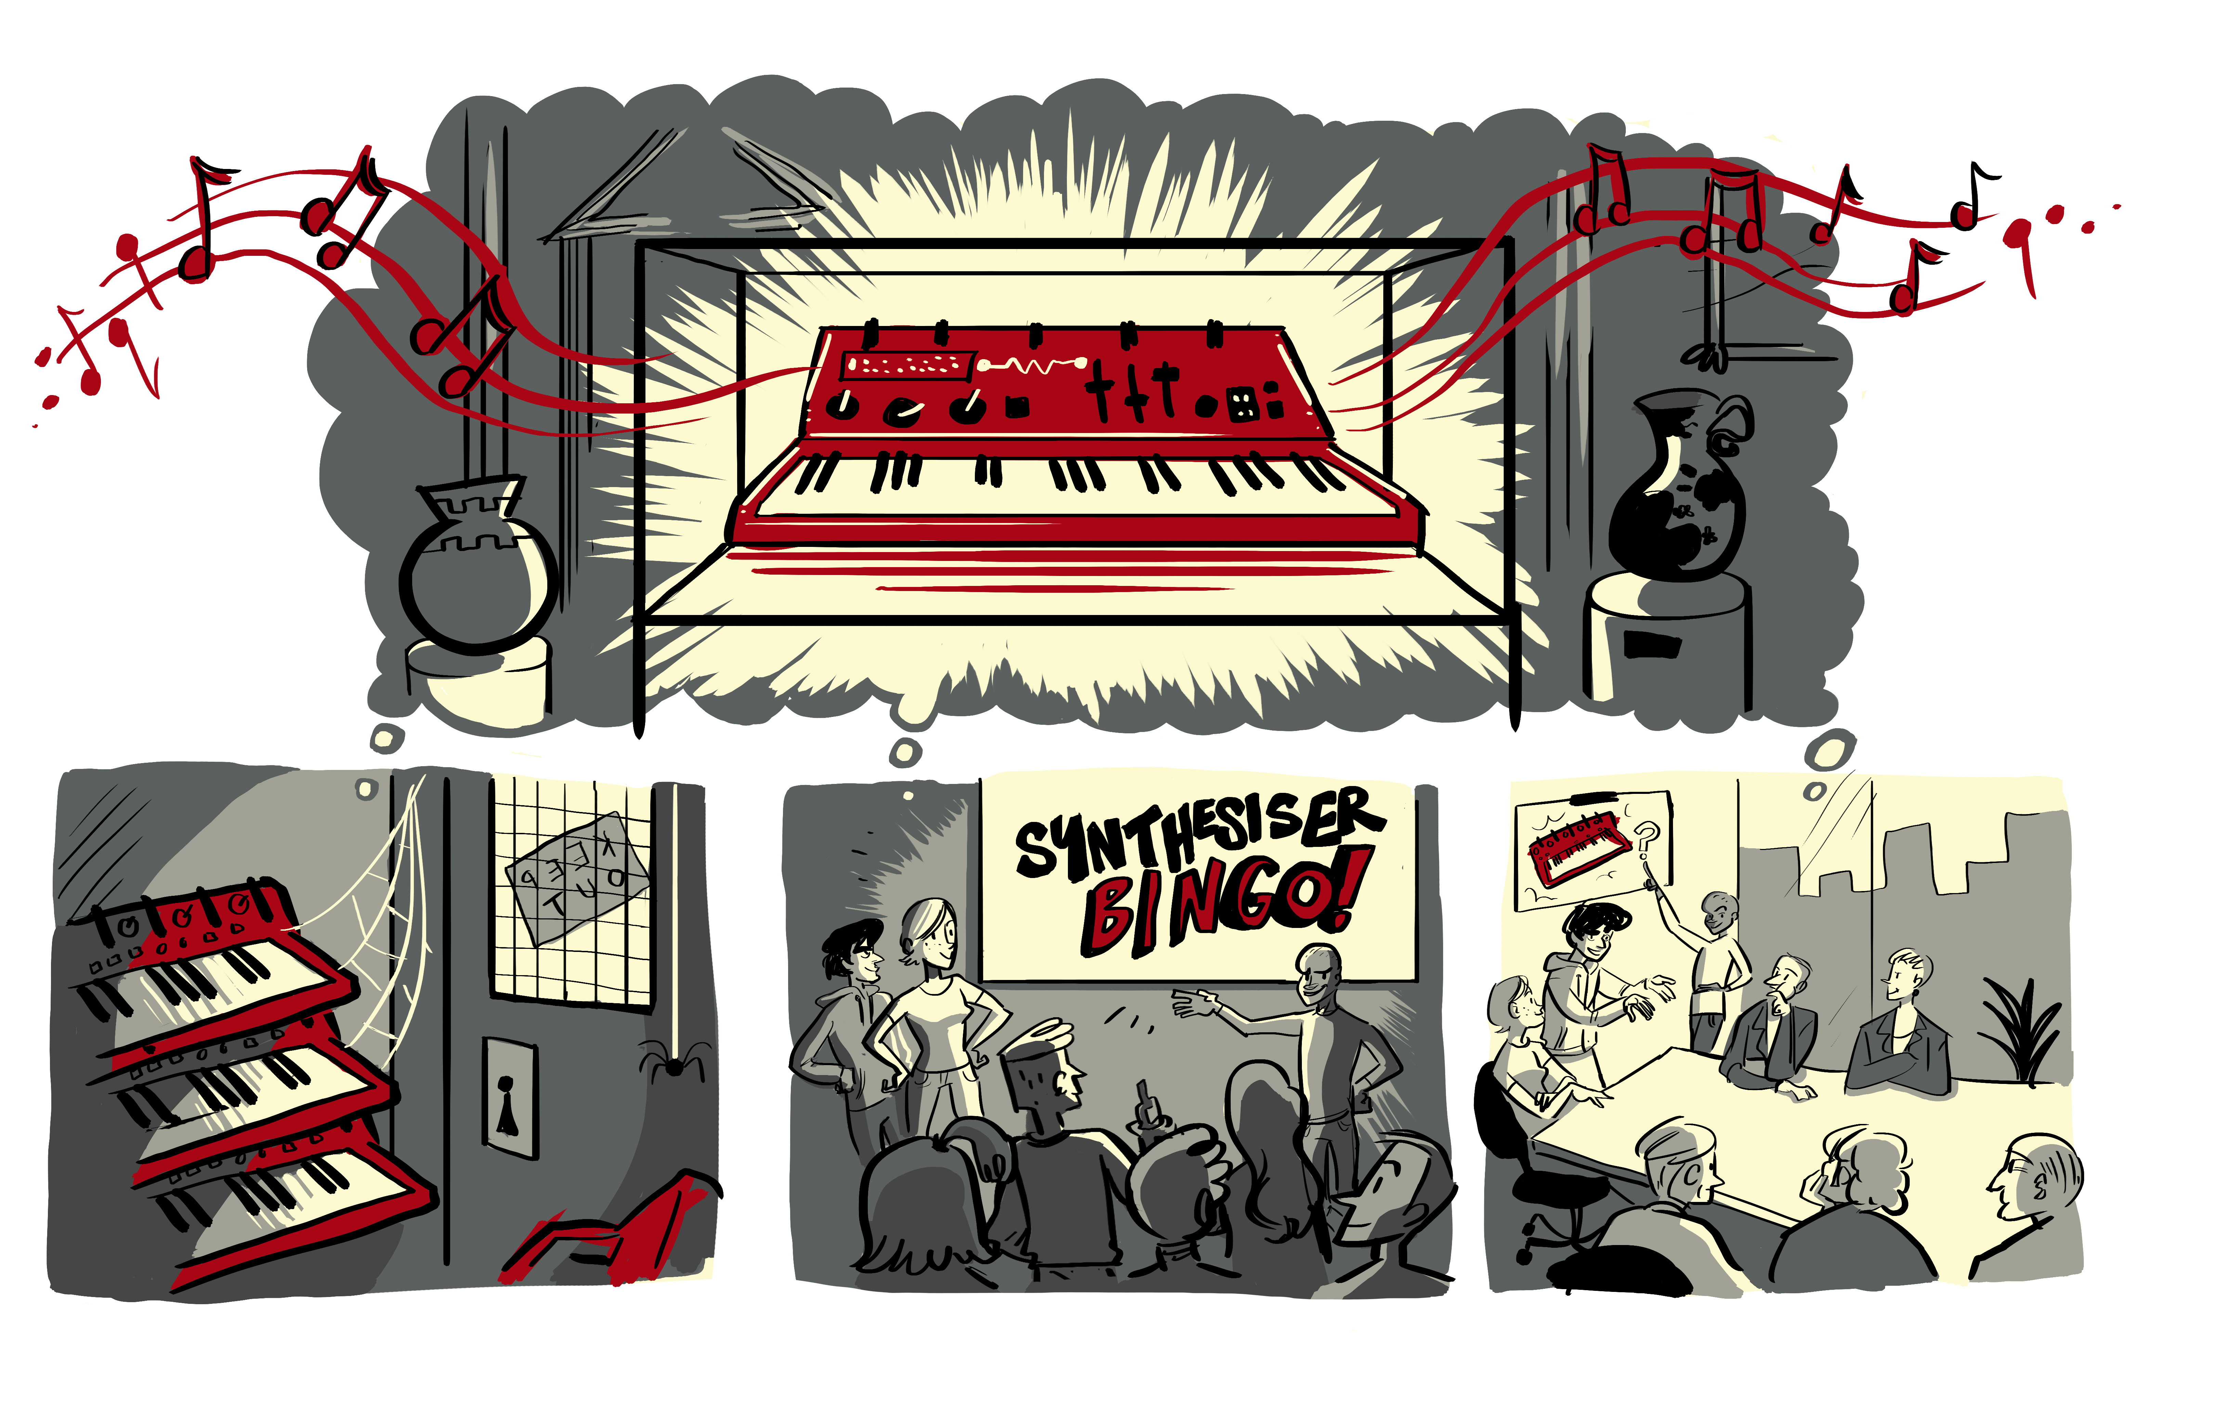
The synth lives! The Science Museum project showed that it wasn’t only about deciding what should be collected that was important to increasing participation – but also how museum objects are used.

4) Discovering the Clyde: Organisational reflective practice at the Royal Commission on the Ancient and Historical Monuments of Scotland
A series of reflective interviews – conducted by Rebecca Madgin and Alex Hale – with key staff members involved in the Discovering the Clyde programme allowed different perspectives on what the Royal Commission on the Ancient and Historical Monuments of Scotland ‘should be doing’ to be openly explored and debated.
Rebecca Madgin, Urban Studies, University of Glasgow
The interviews revealed intriguing opinions of what RCAHMs’ purpose; the fusion and conflict between individuals' views of the purpose of RCAHMS and the pressure of internal agendas; the role of external agencies and agendas in shaping the origin, form and content of Discovering the Clyde; the inability in a number of cases to separate professional and innate decision making.
Alex Hale, Royal Commission on the Ancient and Historical Monuments of Scotland
Having now listened to all of the interviews with my colleagues, I have a greater understanding of how affective and effective the programme could become for RCAHMS and the new heritage body in Scotland (Historic Environment Scotland, from October 2015). In addition, this phase enabled me to understand the aspirations of those involved in the programme management, as well as acknowledge the complexities that developing such a programme can entail.
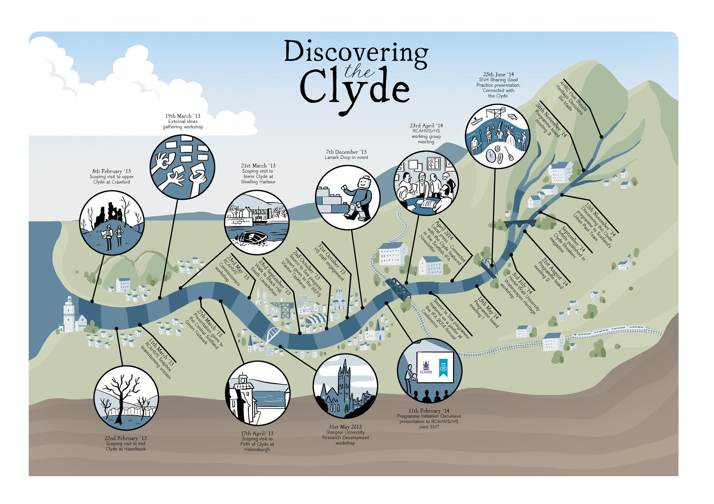
The interviews conducted with those involved in Discovering the Clyde gave a space for organisational reflection.

5) The Potteries Tile Trail: The role of the catalyst and DIY approaches
The local focus for this research strand was The Potteries Tile Trail, a community and crowd-sourced virtual collection of tiles and architectural ceramics found in buildings and public spaces throughout Stoke-on-Trent and further afield. It enabled three members of the research team – Danny Callaghan, who worked on the Tile Trial, Karen Brookfield, Heritage Lottery Fund and Helen Graham, University of Leeds – to reflect on a funding programme, the Heritage Lottery Fund’s ‘All Our Stories’, from two ends of the spectrum and for Danny to draw out and present his principles of a DIY heritage.
Karen Brookfield, Heritage Lottery Fund
In my role at HLF I see a wide range of successful heritage projects from the very large to the very small, but often too late to get inside their skin and learn from their experience. Being part of this research gave me a unique opportunity to be alongside The Potteries Tile Trail as they completed their ‘All our Stories’ project and moved into a new phase. I have been on the journey with them as they set about identifying their ceramic heritage far beyond their local area, building up their Historypin site, widening their contacts and influence, and deciding how to take the project forward.
Danny Callaghan, The Potteries Tile Trail
For years I have found myself trying to get specific people in local councils or conservation professionals interested in what I was interested in. Basically they had other priorities and looking back, I can see I wasted a lot of time running into the same brick wall over and over again. Through the delivery of projects such as The Potteries Tile Trail – and importantly, the time for self-reflection enabled by the research – it suddenly became much more clear that these alternative ways of operating are not only possible but also highly effective in delivering results. This approach enables individuals and communities to make decisions for themselves and act without 'asking for permission'.
6) York: Living with History – situating participation in heritage decision making in a city’s systems
York is known as a heritage city. Mapping heritage decision-making systems – and crucially how they these systems are experienced by the people who live in the city – made clear the urgent need for alternatives to traditional forms of ‘consultation’. Instead the York team experimented with participative approaches focused – not so much on ‘sharing your opinion’ or ‘having a say’ – but on action and argument.
The problem of ‘they’ and of ‘consultation’: Use of ‘they’ was directly linked to people’s experiences of ‘consultation’ as the most common organizational attempts at ‘participation’. The main conversations we had suggested how counterproductive consultation was, cultivating a perception that it was only a ‘fig leaf’ for decisions that already been taken.
The politics of networks: they are great if you’re in them and very hard if you’re not.
Richard Brigham and Lianne Brigham, York Past and Present
We do Urban Exploring and all we wanted to do is go in and take some photographs of some ex-military hutments before they were demolished. We tried everything to get permission to go in. We phoned the Council. We got passed on to the Art Gallery. Then they passed us back to the Council. We were passed from pillar to post. Even to the point that we asked a security guard to take our camera and take photos – and the answer was still no. We thought we’ve had enough, we’re going to start something new. Start afresh. That’s when we started the Facebook group – now over 7000 strong – York Past and Present.
Experimental action: We devised a series of experimental public events, which aimed to model ways of breaking down the division of ‘us’ and ‘them’ by diversifying who is included in the informal networks influencing heritage in York, by ‘humanising’ those in decision-making positions while also addressing some of the hard-edged critiques of participation we’d unearthed. York Civic Trust led on an event explore the past, present and future of the Castle Area and Eye of Yorkshire.
Peter Brown, York Civic Trust
My organisation has, until recently, functioned in 'silo-mode', considering itself one of a small number of 'experts' engaged in the heritage decision-making process in York. Involvement in this project, however, has shown the benefits of a more democratic and inclusive engagement with a broad spectrum of opinion, thereby offering a more measured view on issues of common interest.
One of the other experiments we did was to run radical history walks. Paul Furness led the walks and we published York: A Walk on the Wild Side as one of the project’s outcomes.
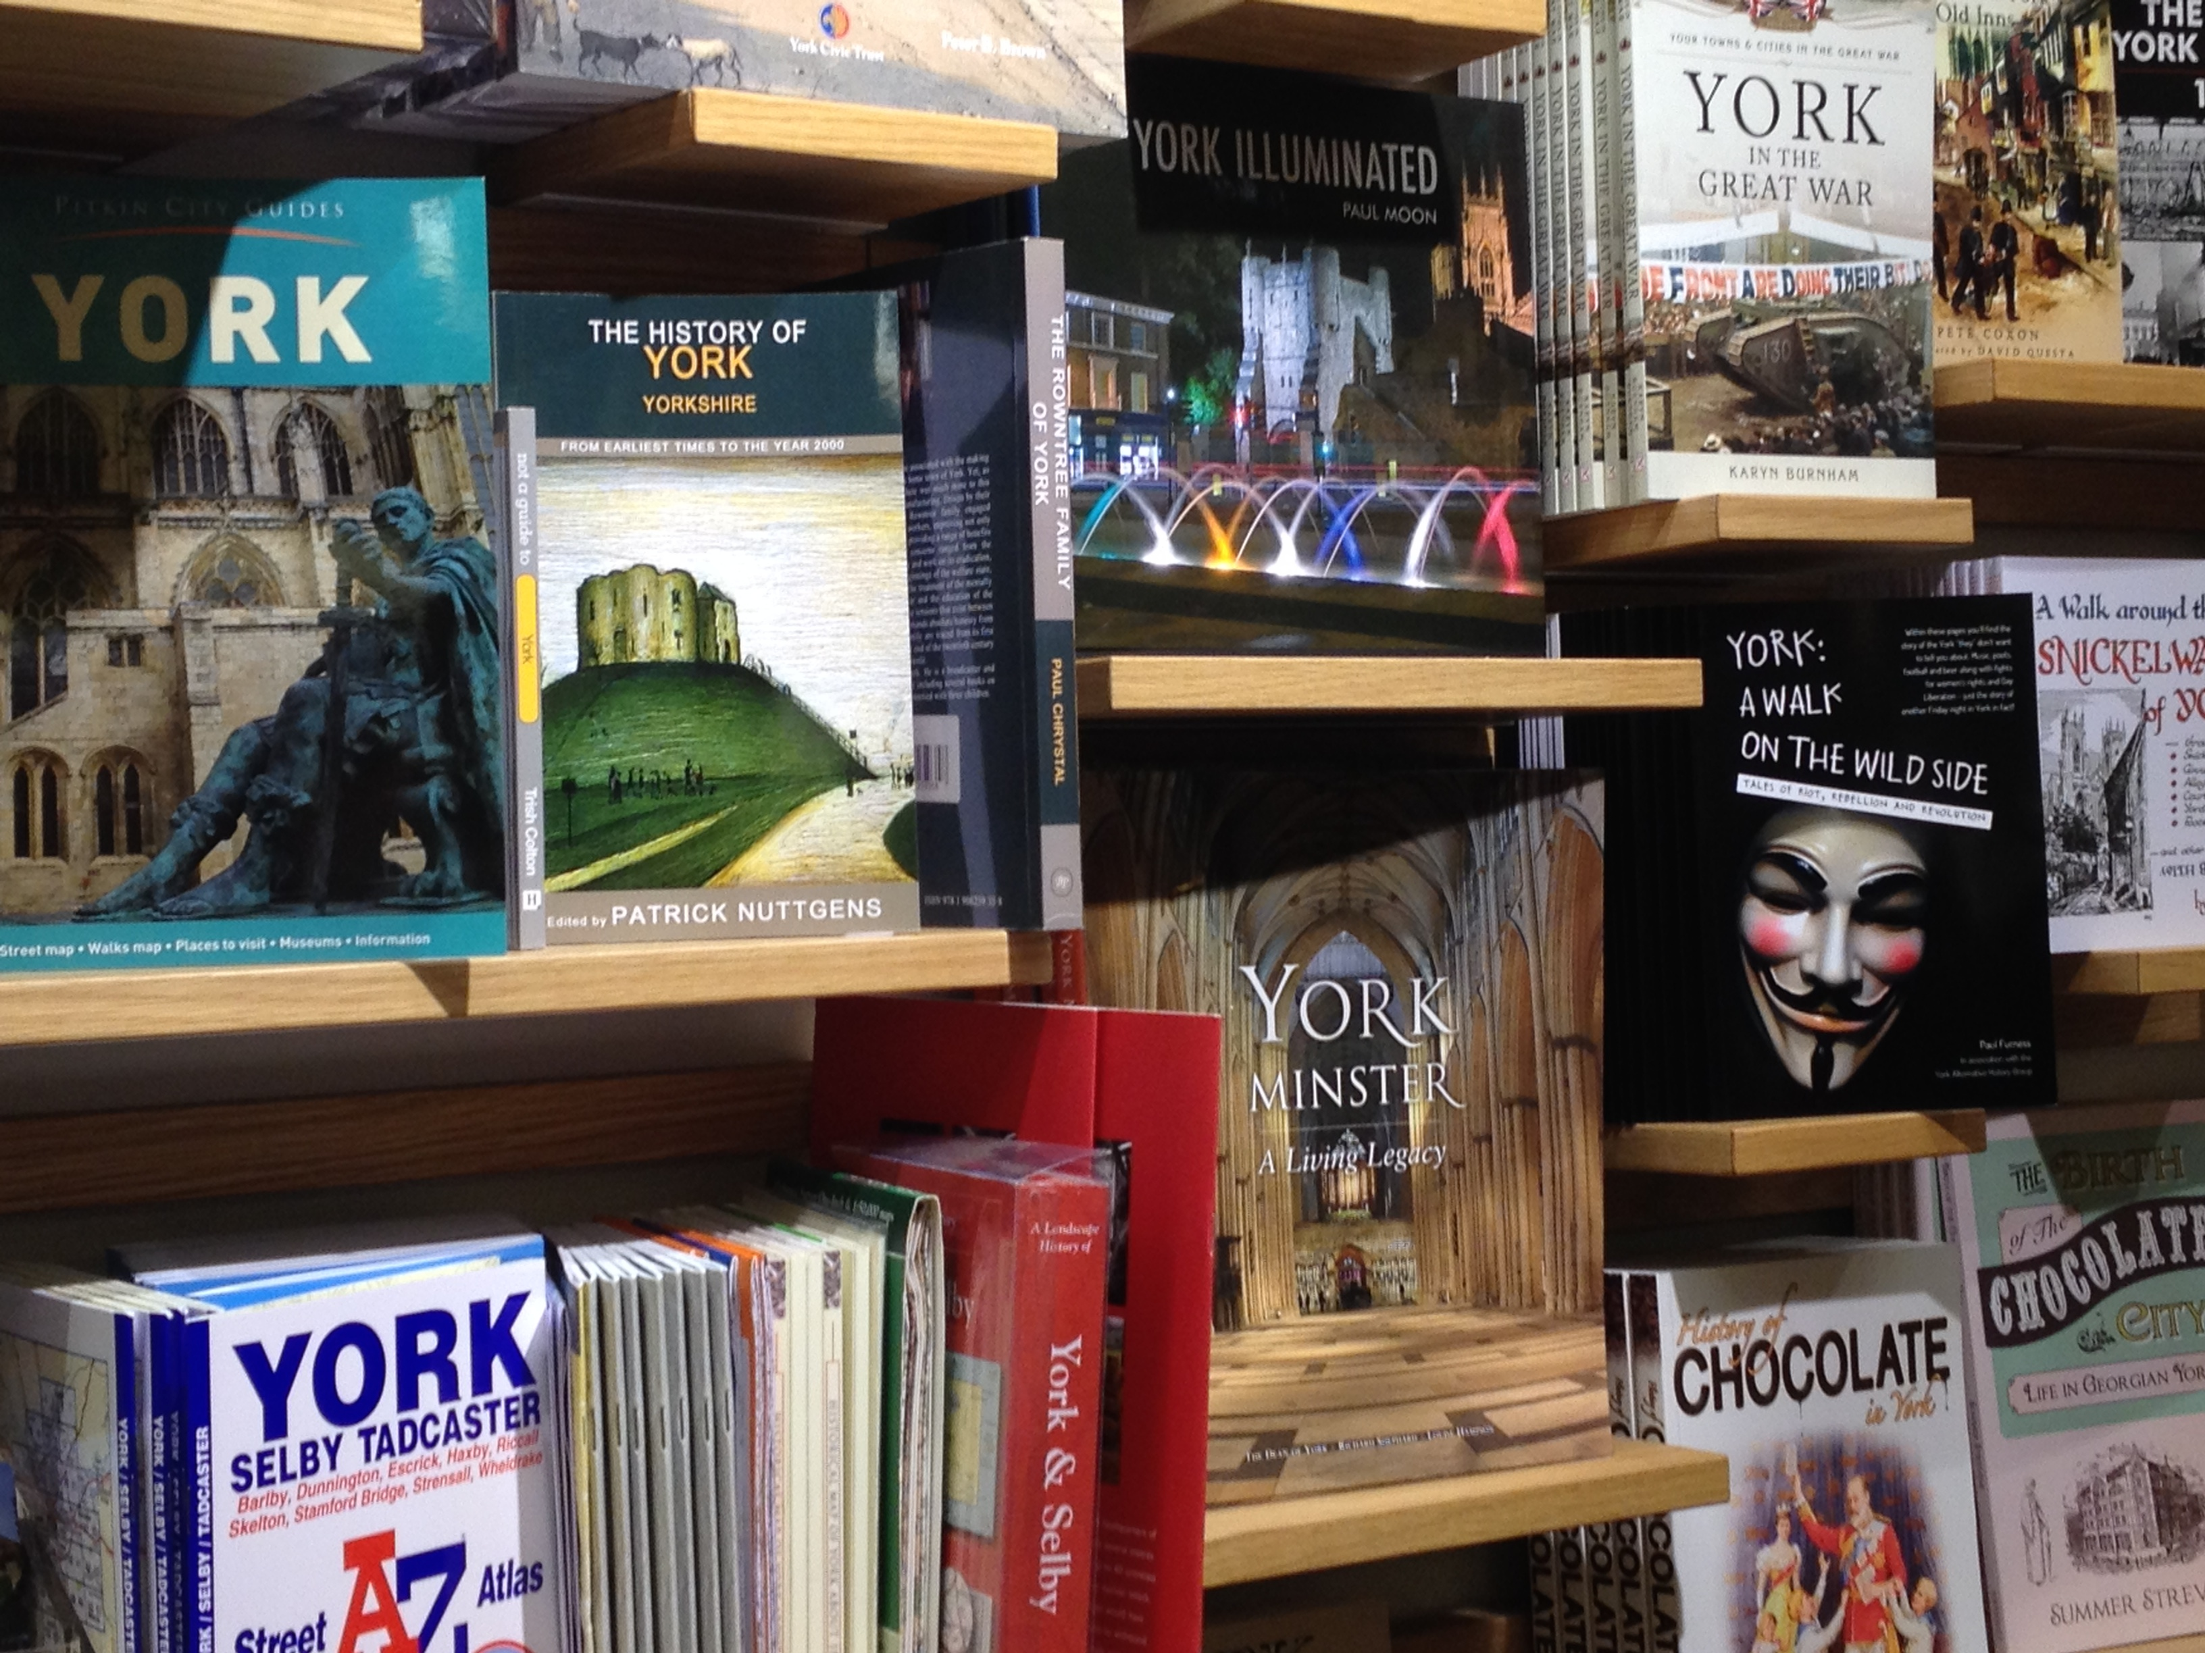
Paul Furness’ book graces York Waterstones’ shelves – the book and accompanying press
generated debate about how the way we think about York’s past affects the city’s present and future.

For more information of the York strand see: www.yorklivingwithhistory.wordpress.com

Testing emerging ideas: Heritage Lottery Fund workshop
Near the end of our research phase we wanted to mirror the MadLab workshop where we tested our design by also putting our emerging insights to the test. We did this in October 2014 with Heritage Lottery Fund staff from the Corporate Strategy team and from local teams in England and Northern Ireland. We shared key ideas from the project to test their resonance and suggested how HLF might apply some of our thinking through five 'provocations' directed specifically towards the Fund.
Ben Greener, Policy Advisor – Historic Environment
[My main reaction] was about the emotions and interconnections generated by heritage. And the ways that we can restrict people’s engagement by only thinking about heritage in linear ‘traditional’ ways. I think that there is a lot for us, as heritage professionals and funders alike, to take away from projects like this and to influence the existing (and future) methods of engagement that we ask applicants to think about when designing their projects.

Fiona Talbott, Head of Museums, Libraries and Archives
How rare it is to have so many working class/regional accents at an event of this type. And how encouraging it was to hear how they had to take on the ‘official' owners of the heritage in order to get a heritage project that they were passionate about up and running. It raises a wider issue for me as to whether local authorities, when faced with difficult decisions around closures, really know sufficient about other options to maintain a service/save a building before just opting for closure or sale.

Key ideas from increasing participation in heritage decision-making:
The following four ideas are the distilled version of our collective thinking – we see these ideas as derived from both the social learning approaches of the project (we learnt constantly by talking with each other) and the experimental action undertaken. You could think of them as forms of ‘know how’.
Each idea expresses practical ways of operating within complex systems – through the power of ‘acting’, ‘connecting’ and trying to ‘situate’ yourself and your work within wider systemic connections and disconnections. We use the idea of ‘reflect’ to draw attention to how important it is to stop and think – but also, and this was the big benefit of the research project itself, to see your work in relationship to others and learn through conversation and dialogue.
Act: Make change from where you are
Through the idea of ‘act’, we wanted to challenge the way ‘heritage’ can be defined by professionals ‘on behalf of’ the public, and then managed ‘for everyone’ and ‘for future generations’. This is dangerous because it is as if the needs of the unknown future are privileged over those of the known present. Because of this ‘heritage’ can often seem to be someone else’s responsibility or, if you do want to take responsibility, it can seem as though you need to wait for people in decision-making positions to initiate, to validate or to give permission.
Danny Callaghan, The Potteries Tile Trail
Action not words. Individuals and small groups of people can and do make a difference – sometimes a highly significant one. You really don't need permission to act in most situations. Frankly, if something matters to me I do something (usually practical) about it. Creativity and lateral thinking are powerful weapons in your battle. Your energy and passion are highly infectious - your actions may be socially contagious. You too can lead heritage decision-making in your area.
Connect: Cross boundaries and collaborate
Here we wanted to encourage people to make connections with others who share your interests and to develop networks across institutional boundaries. All as a way of humanizing decision makers and getting beyond a divisive ‘them’ and ‘us’ mentality.
Tim Boon, Science Museum
I had a slow ‘lightbulb moment’ in the co-collecting project. In Oramics to Electronica, the previous collaborative electronic music project, I had stayed on the museum side of the museum-participant divide. There mine had been a role something like MC. In the co-collecting project by contrast I became much more of an equal in the group. Sure, I was still ‘the man from the Museum’, but the alchemy of the process enabled me to become co-music geek with the others. By the time John, Dave and Martin offered to organise the synth bingo session, a public event we divised, it really was, I think, a participation of people with equal input and status. The implications for curatorship could be profound.
Reflect: See your work through other people’s eyes
One of the most powerful outcomes of our research project – and its collaborative design – was the chance for us to reflect on our own work and become more self-conscious about our approaches and choices. This was made possible through individual conversations between team members and the powerful effect of learning from each other – and now carrying each other’s voice in our heads.
Martin Bashforth, radical family historian and York’s Alternative History
Diversity was present in the Heritage Decisions group itself, opening up the potential for greater collective wisdom. After the first workshop in Jarrow, the event which for me most captured this quality was the workshop in Manchester, where we invited in an equal number and equally diverse range of ‘critical others’ to reflect and comment on our work up to that point. I continue to absorb and reflect on the intellectual impact of that workshop. Apart from that, the deepest influence has come from one-to-one discussions with team members, each of whom has helped me appreciate different viewpoints and perspectives in ways I could never have expected.
Situate: Understand your work in context
We used ‘thinking systemically’ as a research methodology. We also found this technique useful for reflecting on our own practice and activism and for planning action and connection. Basically, if you can see how formal structures and informal networks fit together, then you can start to notice key people and key levers for increasing participation in decision making.
John Lawson, Storyteller, Loftus, Kathy Cremin, Hive and Mike Benson, Bede's World
We believe that folk engage with heritage everyday probably, in truth, in spite of, and not because of, heritage professionals. If we use the metaphor of heritage as a river that flows everyday then one choice is to contain the river and constrain its possibilities and box off opportunities. However, for us, it is the ecology that sustains the river, which is critical. The more streams that feed into the river, big or small – all carrying stories all playing their part in making the river flow – the better. Then the river, and its ecosystem flourishes and begins to sustain the places and spaces through which it flows.

Learning points from Co-design Process:
We end this report by reflecting on the particular effects of the two-stage funding model offered by the co-design development grants.
The strengths of this model and our project:
- Working together and valuing all contributions: It enabled fourteen people – researchers, professionals and activists – to work together and for everyone’s time to be valued and paid for.
- Crucial chance for reflection – and the power of conversation: The project offered space to reflect and meeting a group of people with similar passions and goals but very different ways of working.
- Play with ideas and reflect on your work: Working together allowed for being intellectually stimulated and challenged. The group created a dynamic where we could work through ideas. Part of this was recognising that passion for heritage can take many different forms and involve contradictory value systems, as well as then being able to recognize and acknowledge the validity of those of others.
- Emergent methodology: The two phases of the research allowed us to build a flexible methodology which allowed us to involve more people as we went along – for example Science Museum and in York – and for them to also shape the direction of the sub-strands.
- Being open as a research team to challenge: The ethos of codesign encouraged us to open up our own team, outputs, ideas and processes to outside scrutiny.

If we were doing it again, what we’d do differently:

- More discussion of our principles of working early on and throughout: The principles and ethics of co-design need to be fully understood and accepted by all participants and embedded in the way the project is organized and structured to maximize potential for wide input – we could have discussed this more at the beginning and deliberately returned to it at each workshop. Part of this would be talking more openly about what the role of the Principle Investigator should be.
- Being more self-conscious about how we were collaborating and what that meant: We would have greater discussion about repertoires of collaboration – to enable greater self-conscious choices and greater sense of distributed leadership. We were less a collective working towards consensus than a forum for debate and discussion and then – in our research phase – smaller affinity groups, collaborating together to achieve something we cared about.
- Create better methods for integrating academic theory and approaches: We would take more time to explore the kinds of ‘knowing’ or ‘understanding’ we were hoping to produce – and the contribution of academic knowledge.
- Greater geographic focus: Co-design may well work better in a more localised environment – the challenge of geography was too great. It might have been a stronger project if we’d all worked on one issue, problem or area.

Appendix 1:
Phase 2 Research questions:
- Can we ‘map’ and ‘model’ ‘heritage’ as a complex system?
- Who are the key players? How do they currently interact? How do these vary in different places? How is planning decision making different from community heritage contexts?
- Where are the different ‘decision-making’ points in ‘heritage’ systems?
- How are heritage decisions justified? What ideas are used to justify heritage decision making? (future generations; significance). What does not get seen as a ‘decision’ which should be?
- What is changing around us which is impacting on how ‘heritage’ works (e.g. Localism Act, public sector cuts, philanthropy, changes in governance structures)?
- What other models of decision making could we draw into a heritage context? (deliberative democracy, associative democracy, horizontal decision making, do-it-yourself approaches)?
- What theoretical and conceptual resources from other disciplines might help (complexity theory, systems theory, actor network theory)?
- How might systemic action research as a means of understanding heritage decision making itself help create changes with heritage decision making?

References and external links

References:
Danny Burns (2007) Systemic Action Research: A Strategy for Whole Systems Change. Bristol: Policy Press.

External links:
For more on the project see our website: www.heritagedecisions.leeds.ac.uk
Here you can find our end of project booklet: How should heritage decisions be made?: Increasing participation from where you are.

The Connected Communities

Connected Communities is a cross-Council Programme being led by the AHRC in partnership with the EPSRC, ESRC, MRC and NERC and a range of external partners. The current vision for the Programme is:

“to mobilise the potential for increasingly inter-connected, culturally diverse, communities to enhance participation, prosperity, sustainability, health & well-being by better connecting research, stakeholders and communities.”

Further details about the Programme can be found on the AHRC’s Connected Communities web pages at:

www.ahrc.ac.uk/FundingOpportunities/Pages/connectedcommunities.aspx

